Robert’s Rules of Order: Voting Procedures Explained

Robert’s Rules of Order is a widely used manual for conducting meetings and making decisions as a group. It provides a structured framework for voting procedures, ensuring that meetings are orderly and decisions are made democratically. Understanding these procedures is essential for anyone participating in formal meetings.
Whether you’re leading a corporate board meeting or organizing a committee, Robert’s Rules of Order ensures that voting is fair and transparent. Robert’s Rules also allows for decisions to be made by unanimous consent, streamlining the process when no member objects.
This article will break down the different voting methods under Robert’s Rules, discuss the steps involved in making a motion to vote, and examine how modern adaptations, such as digital voting under Robert’s Rules, fit into today’s digital world.
Types of voting methods in Robert’s Rules
There are several methods of how to vote using Robert’s Rules, each suited to different contexts and levels of formality. Below, we explore the most common ones.
Roll call voting
A roll call vote involves each member stating their vote aloud. Members are called in alphabetical order, and the presiding officer votes last to ensure impartiality. This method ensures transparency and is often used when a formal, recorded vote is required. Every member’s vote is visible to the entire assembly, making it suitable for situations where accountability is essential.
Insight: What is a roll call vote? It is a Robert’s Rules meeting voting method where individual votes are recorded publicly.
Voice and ballot voting
A voice vote (also known as viva voce) is the simplest voting method, where members verbally express their vote by saying “aye” for approval or “no” for opposition. It’s quick and efficient but less reliable for close decisions as it relies on the presiding officer’s auditory judgment.
In contrast, a ballot vote ensures privacy and is used when secrecy is required, such as in elections or for sensitive matters. Each member writes their vote on paper or submits it electronically, which eliminates peer pressure and protects anonymity.
Insight: The difference between a voice vote and a ballot vote lies in transparency: while the voice vote is public and quick, the ballot vote is private and often used for more sensitive decisions.
Steps in the voting process
To ensure an orderly decision-making process, Robert’s Rules outlines a specific Robert’s rules of Order agenda for introducing and voting on motions:
In fact, there are several types of motions:
- Main motion: Introduces a new item for discussion or action.
- Subsidiary motion: Changes or affects how to handle a main motion (must be voted on before the main motion).
- Privileged motion: Concerns urgent or important matters unrelated to current business (e.g., adjournment or recess).
- Incidental motion: Deals with questions of procedure that must be resolved before continuing with other motions.
- Motion to table: Temporarily suspends further discussion or action on a motion (often to kill a motion without a direct vote).
- Motion to postpone: Delays the vote on a motion to a specific time or date, allowing for further consideration.
When such a motion is introduced, it must follow the rules for presentation, debate, and amendment as outlined in Robert’s Rules.
These motions help guide the flow and structure of meetings under Robert’s Rules of Order to ensure organized decision-making.
Making and seconding a motion
The process begins when a member proposes a motion. This is a formal suggestion for action, such as adopting a new policy or approving a budget. The motion must be seconded by another member to indicate that at least two people consider the matter worthy of discussion. Without someone to second the motion, it does not move forward.
For clarity, here’s a Robert’s Rules of Order cheat sheet outlining common actions related to motions and the key procedural requirements around them. This table will help you guide board member on how to conduct a formal vote during a meeting:
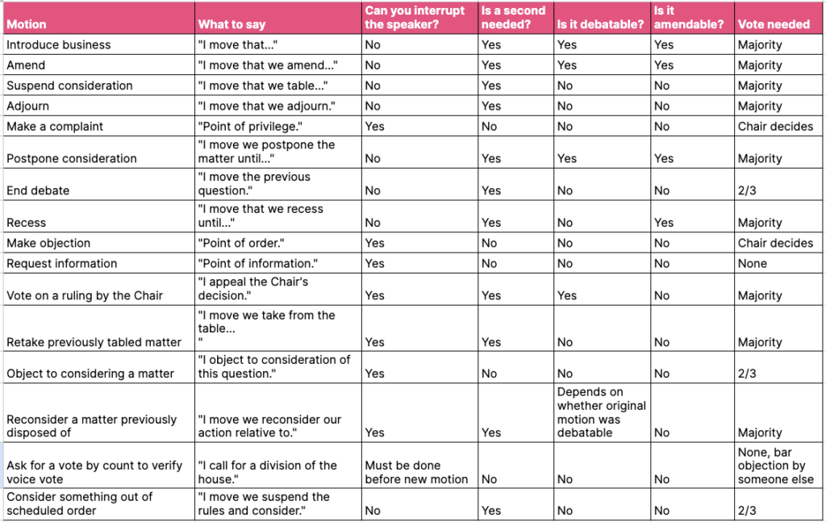
Debate and amendments
Once a motion is seconded, the group can engage in debate. This allows members to discuss the merits of the motion and offer any modifications or a proposed amendment. An amendment to a motion must also be seconded and voted on before returning to the original motion, with or without the proposed changes.
Insight: Knowing how to amend a motion in Robert’s Rules is crucial for members who wish to make changes before the final vote.
Voting majority and quorum requirements
For a decision to be legally binding, certain thresholds must be met regarding the number of members present and the votes cast. Quorum refers to the minimum number of members who must be present for the assembly to conduct business legally.
What is a quorum?
A quorum is the minimum number of members required to conduct business. A meeting cannot proceed unless enough members are present to meet the quorum requirement. Without a quorum, decisions made during the meeting are not considered valid. The exact number needed for a quorum varies by organization but generally represents a majority of members. It’s essential to verify the quorum requirements for meetings before proceeding with any votes.
Voting majority
In most cases, a majority vote — more than half of the members present — is needed to pass a motion. However, for certain decisions, such as amending bylaws or closing debate, a two thirds vote may be required. This higher threshold ensures that significant changes have strong support within the group.
Modern adaptations of voting procedures
With the rise of remote work and virtual meetings, many organizations have adapted Robert’s Rules of Order voting to accommodate digital environments. The same principles apply, but technology allows for virtual voting while maintaining the integrity of the process. Organizations must ensure that digital or email votes are considered legal votes according to their governing documents and applicable laws.
Virtual and digital voting
In virtual meetings, digital voting under Robert’s Rules can be conducted via email, online platforms like Zoom or specialized board management software. These platforms allow members to cast their votes securely and anonymously, mirroring traditional methods while providing flexibility for remote teams. Proxy voting, however, is generally not permitted under Robert’s Rules unless specifically authorized by the organization’s bylaws.
FAQ
Do abstentions affect the outcome of a vote?
No, abstentions do not count as votes under Robert’s Rules. Abstaining members are excluded from the total vote count, meaning they do not influence whether a majority or other threshold is met.
Abstentions are not counted as negative votes; only votes explicitly cast against a motion are considered negative votes.
Can the president vote on motions?
Yes, the president can vote, particularly in cases where their vote can break or make a tie, and in such cases, the president may cast his or her vote. However, it is common for the president to refrain from voting unless their vote is needed to tip the balance and maintain impartiality.

What happens if there is a tie?
If there is a tie, the motion does not pass as it fails to achieve a majority. Further discussion or additional rounds of voting may be required to resolve the issue. A tie vote means that a simple majority has not been reached, so the motion fails.
How do you call for a vote in Robert’s Rules of Order?
To call for a vote, a member must make a motion, which is the proper way to initiate a vote according to Robert’s Rules. After the motion is seconded and any debate concludes, the presiding officer will say, “All those in favor say ‘aye,’ all those opposed say ‘no,’” and proceed based on the responses.
Final word
By following Robert’s Rules of Order, organizations can ensure that their meetings are conducted fairly, efficiently, and democratically. From the various voting methods to the importance of maintaining a quorum, these rules provide a robust framework for decision-making. As organizations increasingly adopt digital voting under Robert’s Rules, these principles remain relevant and adaptable to modern needs.

