Basic Robert’s Rules of Order cheat sheet
Robert’s Rules of Order revolve around a few core principles, which include:
- Parliamentary structure. Debates follow an established structure that dictates how motions or proposals are put forward, considered, and approved or rejected.
- Majority rule. Decisions are taken following majority approval, unless otherwise stated in the company’s bylaws.
- Rights of the minority. Minorities have guaranteed rights, including the right to be heard and to make motions.
- Fairness and civility. The rules help set the stage for a fair and polite debate, keeping tempers and disagreement in check.
The main point of Robert’s Rules of Order
Not every topic at a meeting necessitates a formal motion, but some require a prompt response from the chair. These let participants address procedural issues, request clarification, or express personal concerns without disturbing the meeting’s flow.
- Point of order. Address any rule infractions, incorrect processes, or breaches of established norms.
- Point of information. Request clarification on a motion before voting (do not use it to submit your information).
- Point of inquiry. Seek clarification in a report to make more informed voting decisions.
- Point of personal privilege. Discuss physical pain (temperature, noise), errors in public reporting, or worries about your behavior.
How to make a motion step
There are always outstanding ideas in meetings, but how do we implement them in life? Robert’s Rules of Order helps to go through the formal proposal procedure. In just a few simple steps, you can turn your proposal into a motion.
- Gain recognition. Wait for a gap in the conversation before raising your hand to capture the chair’s attention.
- State your intention. Clearly state, “I move that…” followed by your recommended action. Be detailed and concise.
- Seek support. Wait for someone to “second” your motion, which indicates that others share your interest.
- Clarity rules. The chair restates your move so that everyone understands.
- Discuss and decide. A discussion allows for opportunities for amendments and objections.
- Voting time. Members vote, and the majority decides.
Types of motions
A Robert’s Rules of Order cheat sheet for executive session will usually cover six types of motions:
- Main motion. A new item is introduced to the discussion.
- Subsidiary motion. A motion is put forward to change or regulate the discussion on the main motion.
- Privileged motion. This kind of motion is used when special and pressing matters take precedence over the motion currently under discussion.
- Incidental motion. These are motions that arise during the course of a meeting and can include a point of order, parliamentary inquiry, or request for information.
- Motion to table. This type requests to end a motion.
- Motion to postpone. This one requests to delay the consideration of voting on a motion.
The chairperson’s role
A Robert’s Rules of Order cheat sheet for chair should help ensure the chairperson understands their basic responsibilities and how to conduct the meeting. When presiding over the proceedings, the chairperson should:
- Ensure proceedings are conducted with order and fairness.
- Be impartial and refrain from expressing personal opinions or taking sides.
- Recognize members who wish to speak, maintaining order and meeting etiquette.
- Ensure the rules and procedures for motions and votes are followed.
- The chair should also summarize and restate motions made, ensuring the debate is kept relevant to the motion at hand, being adept at conflict resolution, and knowing when to call for a vote.
Why the cheat sheet for Robert’s Rules of Order is required
Depending on your level of experience with board meetings, it can be very helpful to have a Robert’s Rules of Order cheat sheet handy for small boards. The cheat sheet helps you steer the debate and motions without overlooking any important steps, even if you get nervous and accidentally forget procedures. In this section, read about how to run a board meeting with Robert’s Rules.
How Robert’s Rules of Order meeting cheat sheet can prevent mistakes
Left unorganized, most meetings will soon turn into fruitless arguments. This is why, by having Robert’s Rules of Order cheat sheet for nonprofits or for-profits, you can make sure the right motions are taken and everyone’s time is put to good use.
Common mistakes that occur during meetings include:
- Omitting motions. Debates started without a motion are hard to regulate and cannot be properly registered in meeting minutes or executive session minutes.
- Getting lost in irrelevant discussions. If the chair fails to maintain discipline, board members can easily veer off into personal arguments or debates that miss the point in question.
- Not allowing everyone to speak. Some members are naturally timider, while others are boisterous and assertive. The chairperson should display proper leadership and moderation, making sure everyone is heard.
- Failure to follow proper voting procedures. Robert’s Rules of Order voting cheat sheet provides guidance on how to conduct a vote, including the use of voice votes, show of hands, or ballot votes, as well as the kind of majority required for the vote to pass.
Robert’s Rules of Order cheat sheet board meeting use cases
In the flow of an intense board meeting, it’s easy for even an experienced president to lose the thread of the discussion and allow things to get out of hand. This is why the chair often finds it helpful to implement a cheat sheet when preparing the agenda for the meeting and during the meeting discussions.
Executives new to the role of the chair who plan to run a meeting using Robert’s Rules of Order find it helpful to have a cheat sheet for different meetings, such as a small meeting to discuss minor matters and key meetings with voting on major issues.
How to use the cheat sheet during meetings
Meeting navigation requires both concentration and engagement. During the discussions, some unexpected procedural issues may occur. This step-by-step guide explains how to use a tailored “Rules” cheat sheet for effective meetings.
- Craft your personal cheat sheet. When creating a document, consider important aspects (Order, Information, Inquiry, and Privilege), add personal reminders, and ensure it is easily accessible.
- Focus on engagement. Listen attentively for moments when your cheat sheet can be useful. Be aware of procedural errors, missing information, and distractions. Intervene at the right time.
- Match point to situation. Match points to circumstances using a cheat sheet. It’s important to understand each point’s unique function.
- Seize the right moment. Raise your hand and state your concern or question clearly and respectfully using phrases like “Point of Order,” “For Information or Inquiry,” or “Point of Personal Privilege.”
How to create your own Robert’s Rules of Order cheat sheet
A cheat sheet should encapsulate everything you need to know in order to successfully perform your role in a meeting. It should also contain all the main steps you and other board members will be required to go through, so you can both familiarize yourself with the procedure beforehand and have a reminder handy even at the 11th hour.
Key components of a cheat sheet
Typical elements to include in your cheat sheet would be as follows.
- The order of business. This outlines the typical agenda for a meeting, including the call to order, approval of board minutes, reports from officers and committees, old and new business, and adjournment.
- Motions. It’s important to include a list of common motions and how to go about making them.
- Debate and discussion. The guidelines for participating in debates, including the rules for speaking, time limits, and the requirements for yielding the floor or making a point of order are essential.
- Voting procedures. Your cheat sheet can also outline which types of voting may be used, reconsideration of previous votes, and majority requirements (simple majority, a two-thirds majority, etc.)
Tips for creating an effective cheat sheet
It’s worth keeping a few things in mind as you go about creating your Robert’s Rules cheat sheet for chair.
- Keep it clear. Don’t overstuff your cheat sheet with too much information — add only essential items and easily recognizable information.
- Keep it visual. You want to build a document that’s instantly helpful, where you won’t spend time looking for a given item. Where appropriate, employ a table format such as the one in the section below.
- Keep it simple. Use simple and direct language in the present tense.
- Use prompts. Whether you use a table format, a flow chart, or any other kind of graphic, use prompts to create a memorable and easy-to-grasp scheme. Things like: “I say this”, “Consider item X”, “Can they interrupt? Yes, no”.
- Leverage technology. Use a board meeting template to easily prepare your meeting agendas around the topics to debate.
Meeting script example
The most important thing during the meeting is proper structure. By applying the principles of Robert’s Rules of Order, you will be a confident chairperson, directing the attendees through a productive meeting. Here’s an example script to inspire you:
1. Call to order (7:00 PM):
“Good evening, everyone, and welcome to our quarterly meeting. As per the agenda, I now call this meeting to order.”
2. Approval of minutes:
“The minutes from our previous meeting on [date] have been distributed in advance. Are there any corrections or additions?”
(Address any raised points efficiently.) “Since no further adjustments are proposed, the minutes stand approved as distributed.”
3. Reports (Reports distributed beforehand):
“Moving on to officer reports, we’ll begin with [President’s name]. Please proceed with your summary.”
(President delivers highlights, followed by individual officer reports with action items as needed.)
(For any motions raised, apply the standard voting procedure outlined in Robert’s Rules.)
“Next on the agenda are committee reports. I recognize [chair of the membership committee] to present their findings.”
(Continue the script for remaining reports, addressing motions as they arise.)
4. Standard order of business:
“Now for any new business or outstanding items on the agenda. Please note that this is not the forum for introducing entirely new proposals.”
(Address raised topics efficiently, adhering to procedural guidelines.)
5. Announcements:
“Before we conclude, are there any important announcements from our members?”
(Use this opportunity to confirm details for the next meeting, such as date, time, and location.)
6. Adjournment:
“Having addressed all agenda items, and with no further business to come before this meeting, I now move to adjourn.”
(Confirm any action items and next meeting details before officially adjourning.)
Examples of what to include in a Robert’s Rules cheat sheet
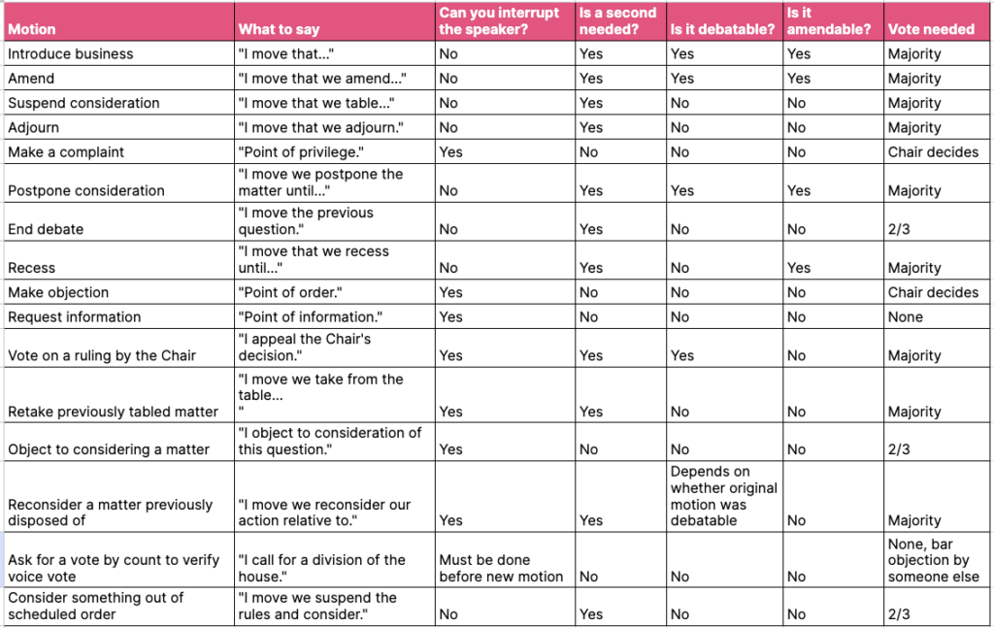
These and other motions can be included in your meeting motion cheat sheet as a way to help you efficiently and speedily navigate any situation during your meetings.
Remember not to just copy and paste a Robert’s Rules motions cheat sheet from the internet. You should adapt it according to your company’s unique aspects — that can include going over the company’s bylaws to understand whether they dictate any special procedures or conditions for committee and board meetings.
Elevate your understanding of parliamentary procedures and foster efficient decision-making. Don’t miss out — grab your cheat sheet now and become a master of Robert’s Rules of Order!
Access Your Cheat Sheet Example now!
Download your cheat sheet
Download
The bottom line
Whether in political or business debates, parliaments, or board meetings, Robert’s Rules of Order continue to be applied for a good reason: this is an essential way to keep debates organized, clean, and productive.
While you may not have had to acquaint yourself with these rules before, we hope the above tips on how to create your own Rules of Order cheat sheet will see you through your next meetings.
That said, you should not rely on them alone. If you’ve been selected as chair of a board or committee or simply want to understand how to properly act in a non-leadership role, pick up the latest edition of this classic book — Robert’s Rules of Order Newly Revised.
You can also greatly increase the effectiveness of your meetings through the proper use of board portals. iDeals, the top choice among the many options available, will help steer you through planning your agenda, collecting votes, writing meeting minutes, and more.
Time to use the modern board management software!
Ideals Board serves board of directors, committee members with a comprehensive suite for governance tools
Visit Website
FAQ
Do I need to have a cheat sheet for Robert’s Rules of Order if I’m not the chairperson of a meeting?
The cheat sheet is not as important if you’re not acting in the capacity of the chairperson or planning to run a meeting using Robert’s Rules of Order. That said, it can be very helpful to have a cheat sheet if you’re not yet familiar with the correct proceedings, including the types of motions and the principles of debate.
Can I customize my Robert’s Rules of Order cheat sheet to fit my specific meeting needs?
Absolutely. In fact, as mentioned above, a good cheat sheet should certainly take your company’s specific needs and conditions into consideration. It may be a good idea to create your own cheat sheets in Excel following a board meeting agenda template, and then fill out and/or add fields as per your requirements.
Are there any digital tools or apps available for creating a cheat sheet for Robert’s Rules of Order?
Yes. Among other software for board management, board portals will help you create and organize Robert’s Rules of Order cheat sheet, as well as facilitate agenda setting, voting procedures, and the preparation and distribution of meeting minutes.
Is Robert’s Rules of Order used in online meetings?
Definitely! Virtual board meetings benefit from proper, structured discussions of the issues at hand just as much as in-person meetings. In fact, the Rules of Order are even more important given the additional difficulties to communication that the internet sometimes brings.

